

**MACHINE LEARNING LAB (AIL-301)**

**BSAI (5A) - Term: Fall 2023**

**HEALTH PREDICTING SYSTEM**

**Submitted by:**

MUHAMMAD ANAS SHAH (02-136212-033)

MAIMOONA SABIR (02-136212-047)

**Submitted To:** *MISS ZAHIDA NAZ* **Submitted On:** Date: 10 Jan 2024

**BAHRIA UNIVERSITY KARACHI CAMPUS**

**DEPARTMENT OF COMPUTER SCIENCE**

Table of Contents

ABSTRACT 3

INTRODUCTION 4

PROJECT OVERVIEW 4

PROBLEM STATEMENT 4

KEY FEATURES 5

USER AUTHENTICATION 5

DASHBOARD 5

HEALTH REPORT GENERATION 5

EMAIL FUNCTIONALITY 5

DATA VISUALIZATION 5

PERIPHERAL ARTERIAL DISEASE (PAD) CHARTS 5

HEART DISEASE CHARTS 5

EARLY DETECTION CHATBOT 5

CHATBOT FUNCTIONALITY 6

HEART DISEASE PREDICTION 6

PERIPHERAL ARTERY DISEASE (PAD) PREDICTION 6

THRESHOLDS AND RECOMMENDATIONS 6

JSON FILE 6

OUTPUT SCREENSHOTS 7

CONCLUSION 8

REFERENCES 9

# TABLE OF FIGURE

Figure 1 HOME PAGE 8

Figure 2 DASHBOARD 8

Figure 3 HEART DISEASE CHART 9

Figure 4 PAD CHARTS 9

Figure 5 PATIENTS DATA 10

Figure 6 LOGIN PAGE 10

Figure 7 REGISTRATION PAGE 11

Figure 8 CHATBOT PAGE 11

Figure 9 ABOUT US PAGE 12

Figure 10 FEEDBACK PAGE 12

# ABSTRACT

The Health Prediction System is an integrated web application designed to empower users with personalized health insights and predictions. Built on the Flask framework, the system encompasses user authentication, health report generation, email functionality, and diverse data visualizations. It employs robust security measures, including hashed passwords, to ensure the confidentiality of user information. The dashboard offers an intuitive interface, presenting interactive charts for heart disease prediction and Peripheral Arterial Disease (PAD). Users can generate detailed health reports in PDF format, providing a comprehensive overview of their health status. The application further enables the secure delivery of these reports via email, enhancing user communication. Leveraging Chart.js, the system offers a range of visualizations, fostering dynamic exploration of health data. The Peripheral Arterial Disease (PAD) charts provide specific insights into diagnosed cases, lifestyle factors, and age-related distributions. This abstract highlights the system's comprehensive features, security measures, and potential for user engagement, serving as a foundation for further development in personalized health management.

# INTRODUCTION

Health Prediction System is a comprehensive web application designed to provide users with personalized health insights and predictions. The system integrates user authentication, health report generation, email functionality, and various data visualizations, making it a versatile tool for health monitoring. Leveraging Flask, a web framework in Python, the system prioritizes user security through measures like hashed passwords to safeguard sensitive information.

## PROJECT OVERVIEW

The project encompasses a user-friendly dashboard, offering interactive charts for heart disease prediction and Peripheral Arterial Disease (PAD). Users can generate detailed health reports in PDF format, providing a holistic view of their health status. The system's versatility extends to secure email delivery of these reports, enhancing user communication. Additionally, data visualizations, powered by Chart.js, contribute to a dynamic exploration of health data.

## PROBLEM STATEMENT

The Health Prediction System addresses the need for a user-centric and secure platform for health monitoring. With increasing health awareness, individuals seek personalized insights into their well-being. Existing systems may lack integration, security, or user engagement features. The proposed system aims to bridge these gaps by providing a consolidated platform for health predictions, comprehensive reporting, and secure communication, thereby addressing the evolving needs of health-conscious users.

# KEY FEATURES

## USER AUTHENTICATION

The system prioritizes user security with robust authentication. Users can register securely, and passwords are hashed for enhanced protection. The authentication process is seamless, ensuring a user-friendly experience while safeguarding sensitive information.

## DASHBOARD

The centralized dashboard serves as a hub for health-related insights. Interactive charts and visualizations provide a quick overview of heart disease prediction and Peripheral Arterial Disease (PAD). Users can easily grasp their health status through intuitive visuals.

## HEALTH REPORT GENERATION

Users can generate detailed health reports in PDF format, utilizing the ReportLab library. These reports include crucial patient information, medical advice, and a disclaimer. The generation process ensures accuracy and visually appealing documentation.

## EMAIL FUNCTIONALITY

The application facilitates the secure delivery of health reports via email, utilizing the Outlook SMTP server. This feature enhances user engagement and communication, providing a convenient means of accessing health information.

## DATA VISUALIZATION

Leveraging Chart.js, the application offers diverse visualizations, including scatter plots, bar charts, line charts, radar charts, area charts, pie charts, and histograms. Users can dynamically explore health data, gaining insights into factors such as blood pressure, cholesterol levels, stress levels, and more.

## PERIPHERAL ARTERIAL DISEASE (PAD) CHARTS

In addition to heart-related visualizations, the system provides specific charts related to PAD. Users can explore diagnosed PAD cases, smoking habits, cholesterol levels, stress levels, age distribution, physical activity, BMI distribution, and diet distribution. These visualizations contribute to a comprehensive understanding of cardiovascular health.

## HEART DISEASE CHARTS

The system incorporates various charts specific to heart disease prediction. These charts provide insights into age distribution, gender distribution, chest pain types, blood pressure, cholesterol levels, fasting blood sugar percentages, abnormal rest ECG occurrences, average maximum heart rate, exercise-induced angina, average ST depression, upsloping slope percentages, average major vessels, thalassemia types, and overall heart disease prevalence. These visualizations offer a detailed analysis of key factors influencing heart health.

## EARLY DETECTION CHATBOT

The system features a chatbot for early detection. Users can interact with the chatbot to receive preliminary insights into their health status. This proactive approach enhances the overall health monitoring experience and encourages users to stay vigilant about potential health risks.

# CHATBOT FUNCTIONALITY

The chatbot designed to predict the risk of two distinct diseases, namely heart disease and Peripheral Artery Disease (PAD). The chatbot engages users in a conversation by posing health-related questions, to which users respond. The chatbot extracts numerical information from these responses for further analysis.

## HEART DISEASE PREDICTION

When the chatbot encounters a set of questions related to heart disease, it employs a logistic regression model for prediction. The numerical values extracted from the user's responses are scaled appropriately and input into the model. The logistic regression model, having been trained on relevant data, produces a probability score indicating the estimated risk of heart disease for the user. The chatbot then communicates this risk to the user and provides actionable recommendations based on the predicted probability. Additionally, the chatbot updates a JSON file with the user's information, including the predicted probability of heart disease.

## PERIPHERAL ARTERY DISEASE (PAD) PREDICTION

Similarly, when the chatbot encounters questions related to Peripheral Artery Disease (PAD), it employs a random forest model for prediction. The user's numerical responses are processed similarly, and the model produces a probability score for the risk of PAD. The chatbot communicates the estimated risk to the user, offering guidance and updating the JSON file with the relevant information.

## THRESHOLDS AND RECOMMENDATIONS

Throughout this process, the chatbot employs predefined thresholds to categorize the predictions into binary outcomes, such as high or low risk. Based on these thresholds, the chatbot provides personalized recommendations to the user. These recommendations may include actions such as consulting with healthcare providers, undergoing further evaluation, or maintaining regular check-ups for overall well-being.

## JSON FILE

The JSON file serves as a repository for user data and predictions, facilitating the storage and retrieval of health-related information. The chatbot also includes prompts for users to generate detailed health reports if they desire more comprehensive insights into their predicted risks and associated recommendations.

# OUTPUT SCREENSHOTS

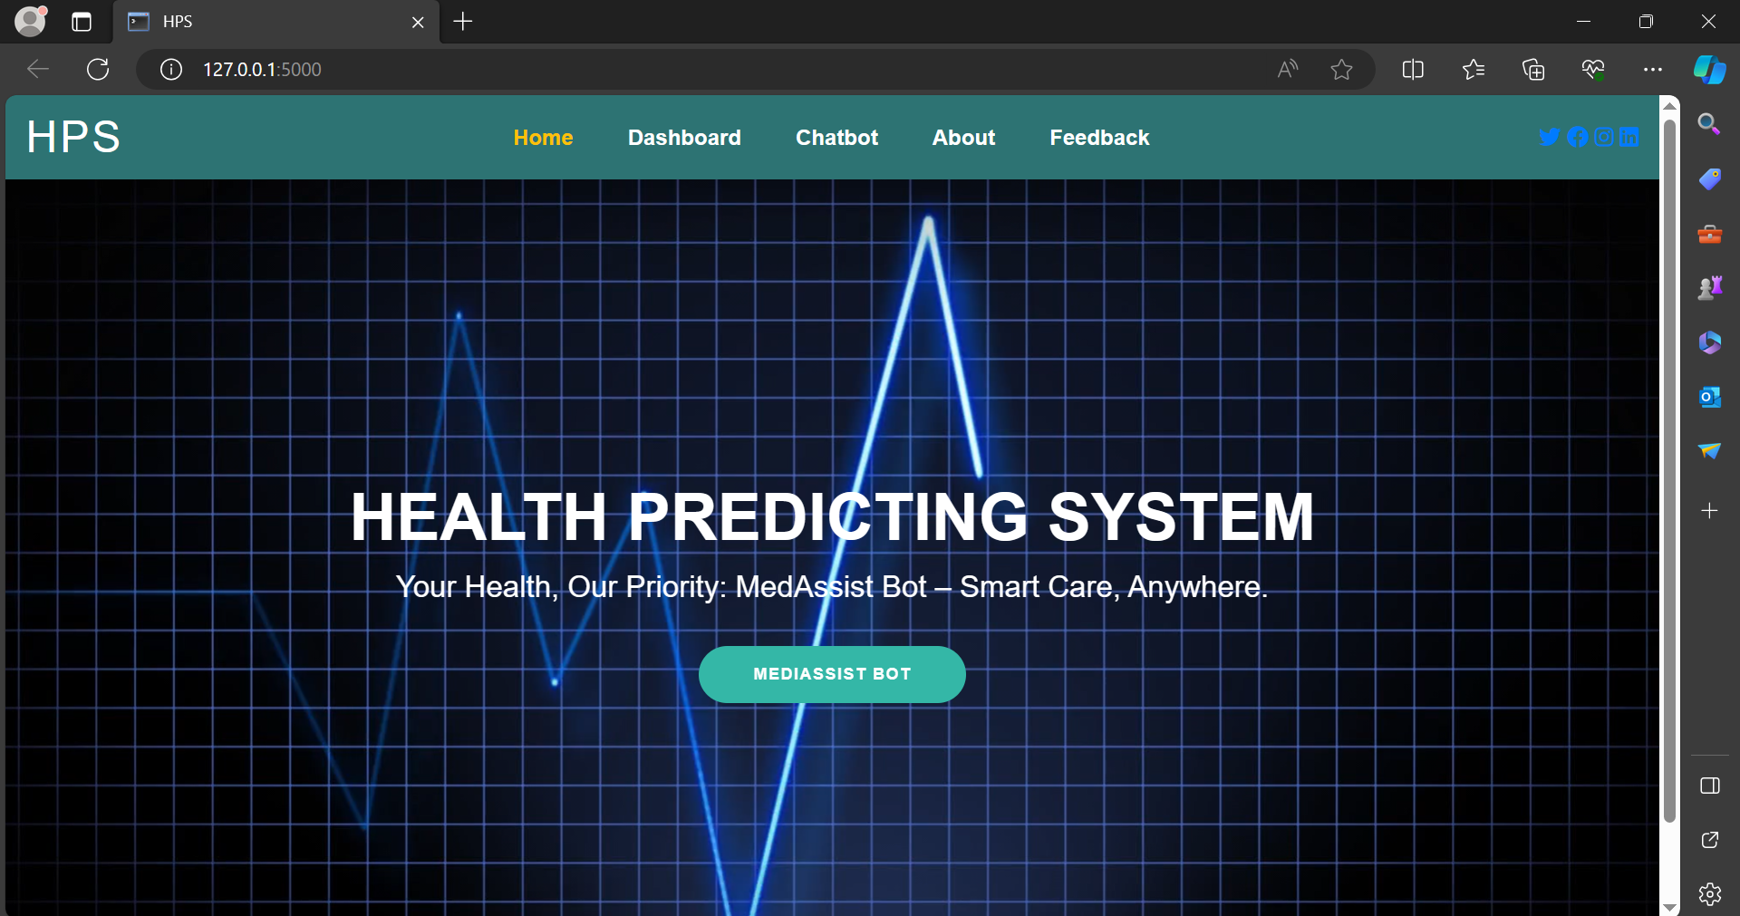

Figure HOME PAGE

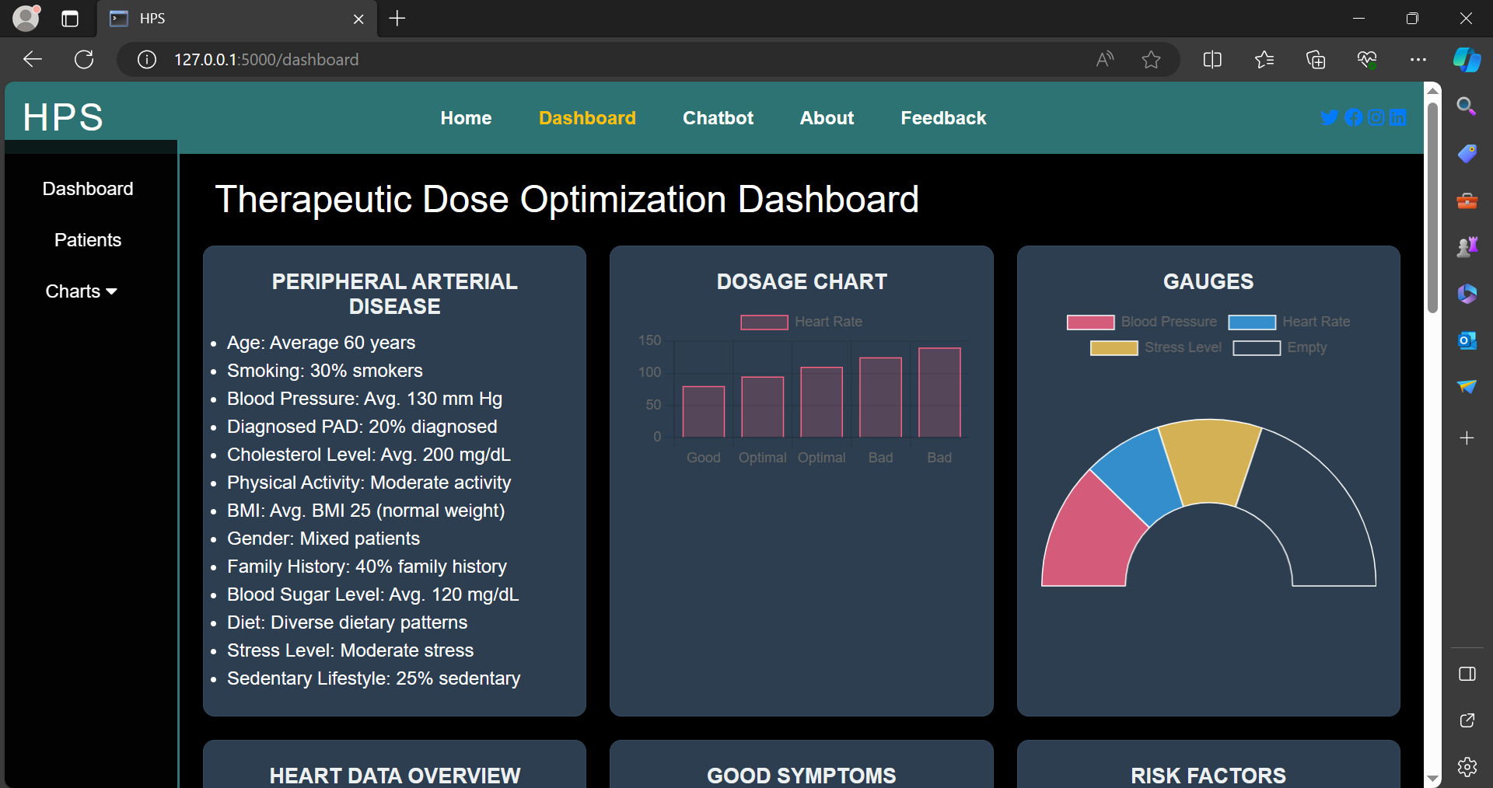

Figure DASHBOARD

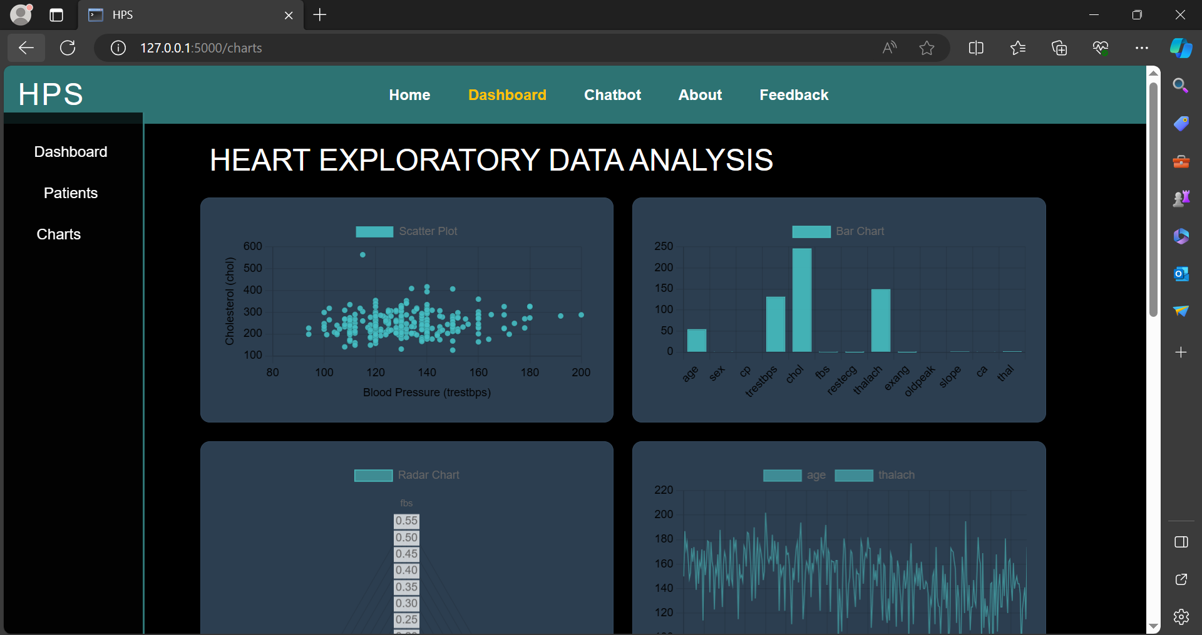

Figure HEART DISEASE CHART

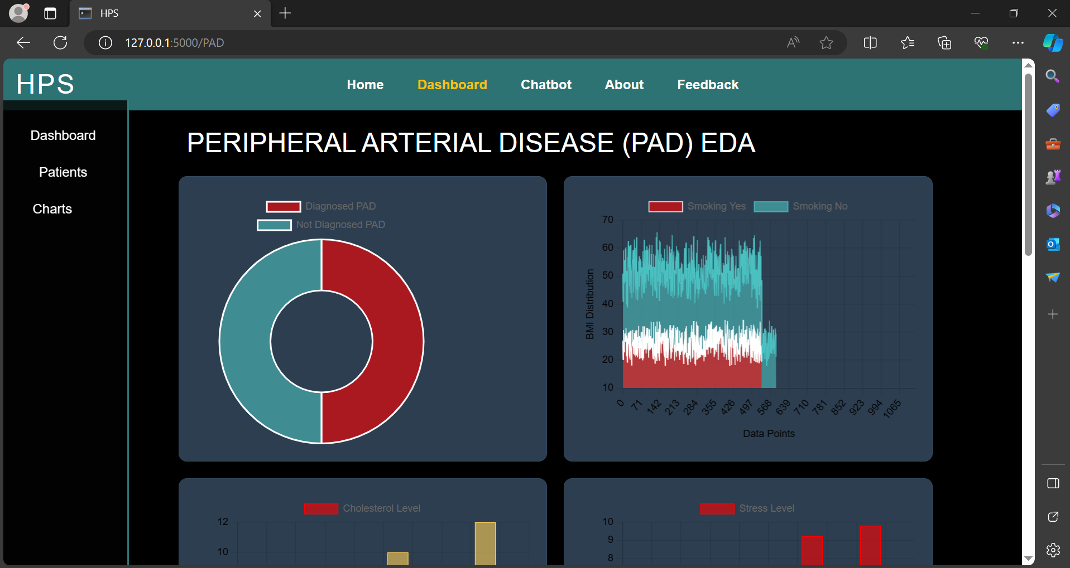

Figure PAD CHARTS

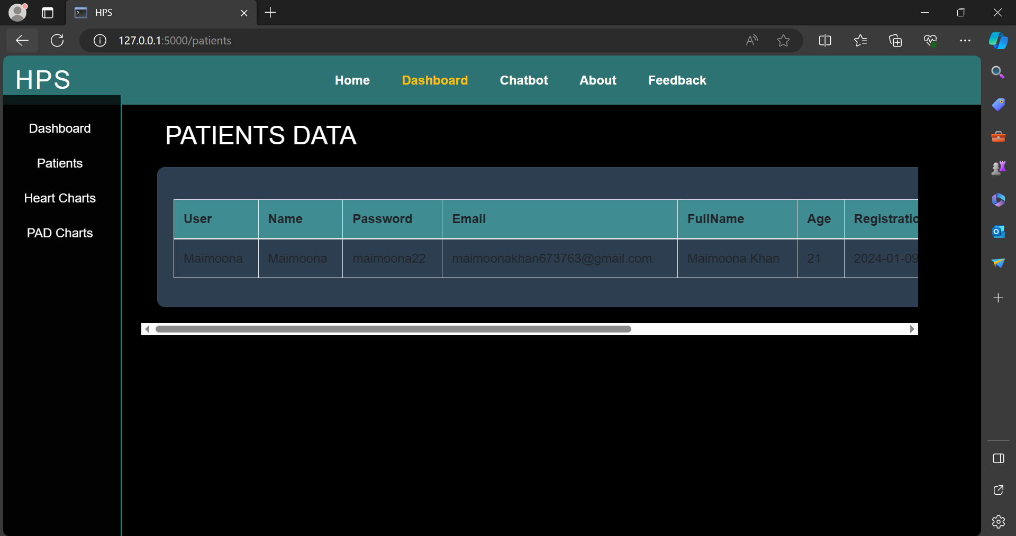

Figure PATIENTS DATA

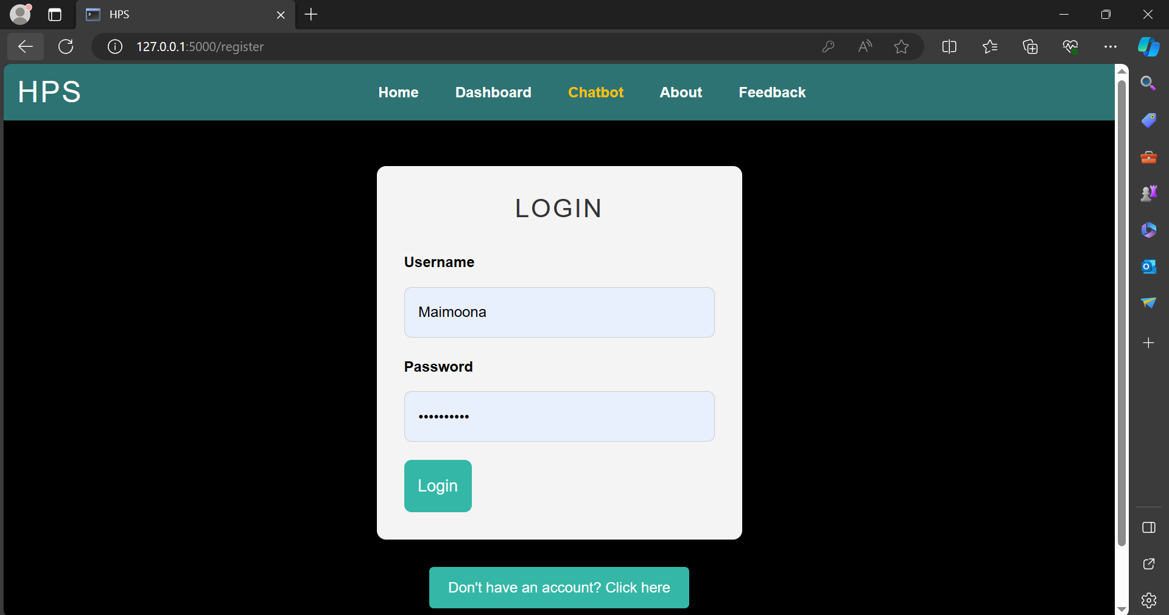

Figure LOGIN PAGE

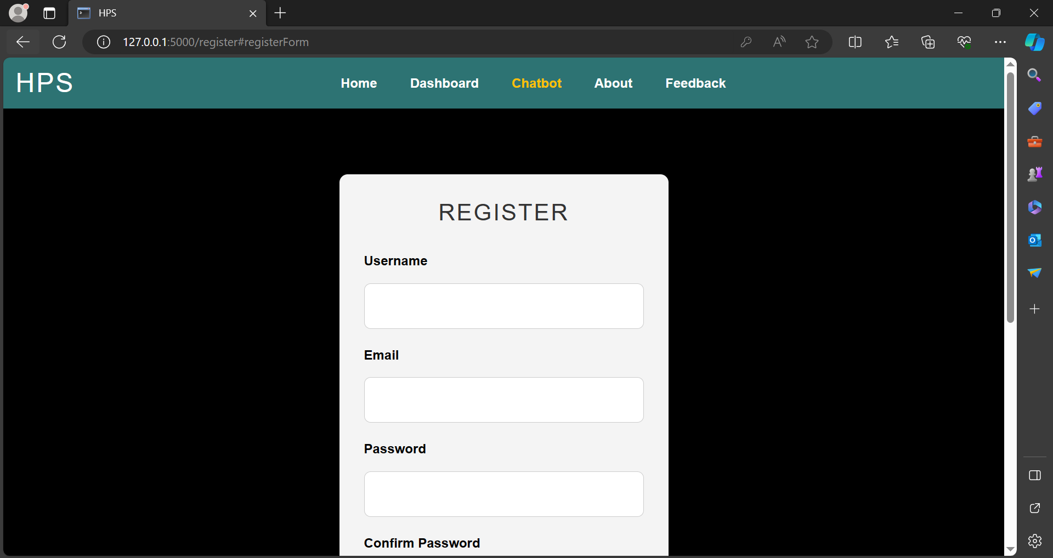

Figure REGISTRATION PAGE

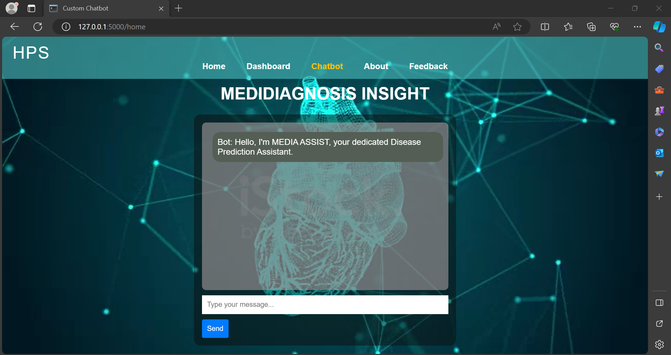

Figure CHATBOT PAGE

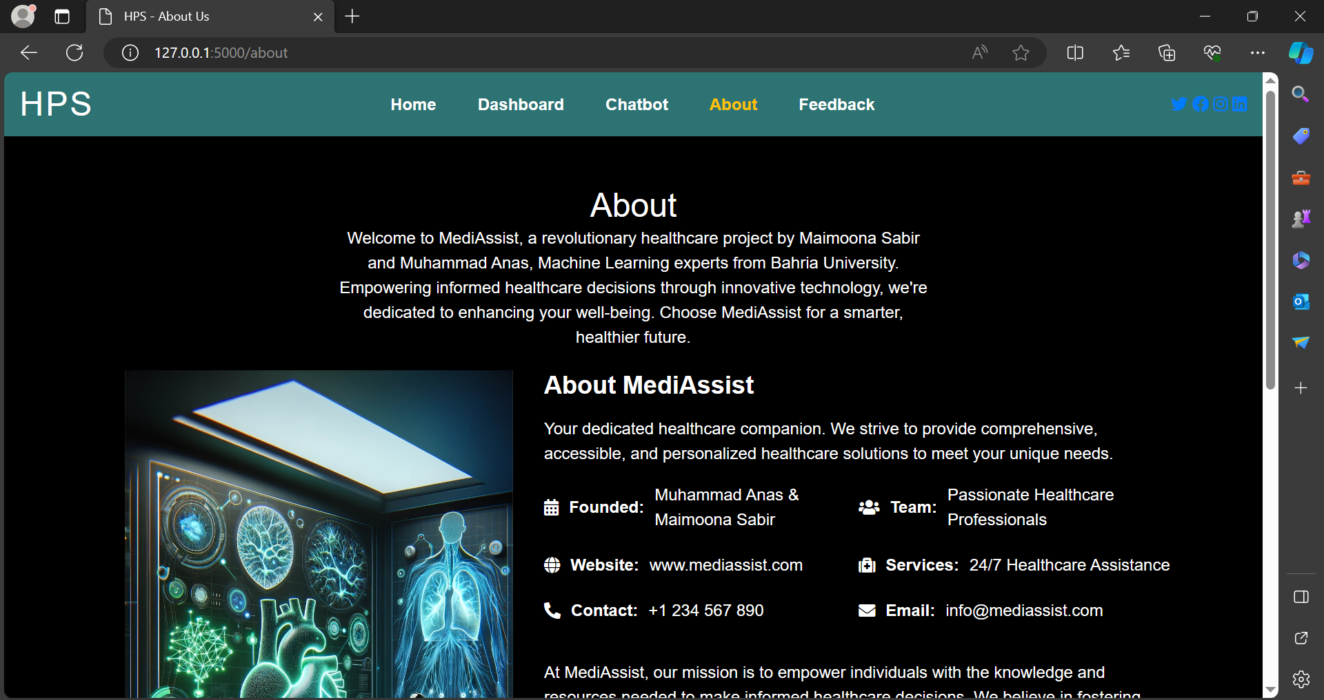

Figure ABOUT US PAGE

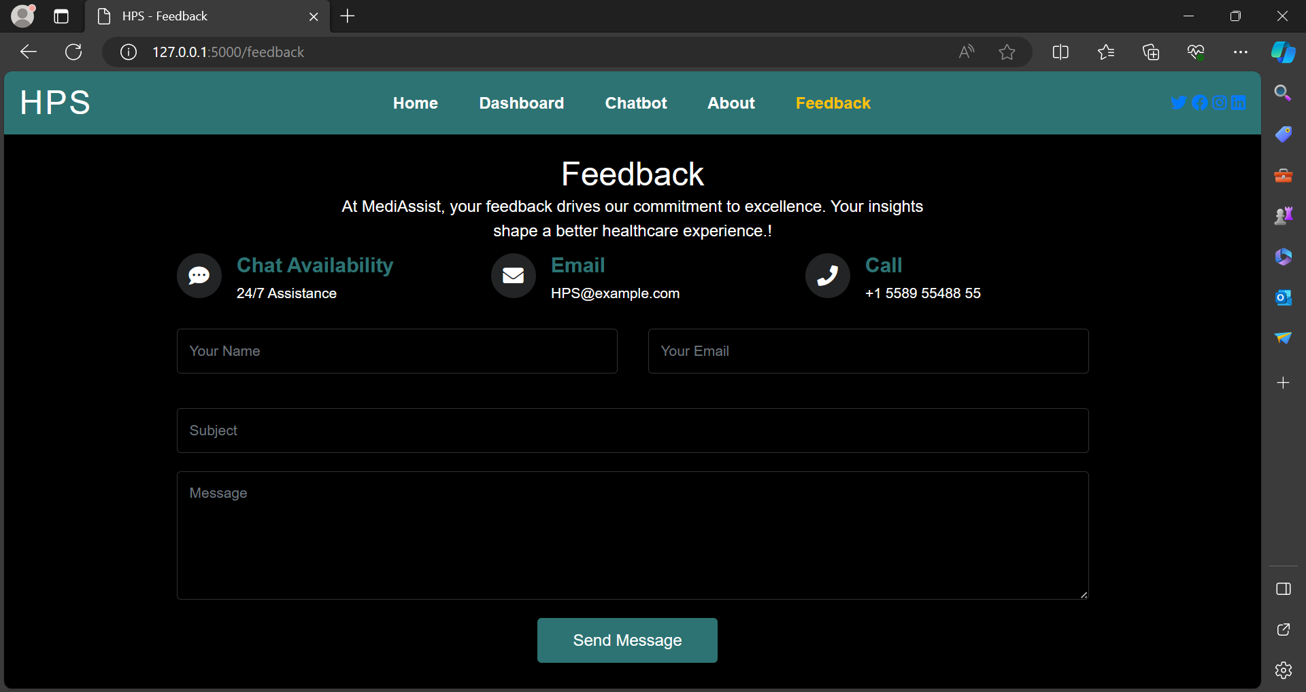

Figure FEEDBACK PAGE

# CONCLUSION

In conclusion, the presented code encapsulates a health-oriented chatbot aimed at predicting heart disease and Peripheral Artery Disease (PAD) risks through machine learning models. By systematically processing user responses, scaling numerical data, and applying logistic regression and random forest models, the chatbot delivers personalized risk assessments. The incorporation of dynamic JSON file updates allows for historical user data tracking and report generation. This virtual health assistant stands as a proactive tool, utilizing predictive modeling and conversational interfaces to foster individualized health dialogue. For optimal effectiveness, ongoing refinement based on user interactions and model accuracy is essential. The chatbot acts as an empowering resource, encouraging users towards informed health decisions and well-being.

# REFERENCES

Jordan, M.I. and Mitchell, T.M., 2015. Machine learning: Trends, perspectives, and prospects. *Science*, *349*(6245), pp.255-260.

El Naqa, I. and Murphy, M.J., 2015. *What is machine learning?* (pp. 3-11). Springer International Publishing.

Carleo, G., Cirac, I., Cranmer, K., Daudet, L., Schuld, M., Tishby, N., Vogt-Maranto, L. and Zdeborová, L., 2019. Machine learning and the physical sciences. *Reviews of Modern Physics*, *91*(4), p.045002.

Chaabene, W.B., Flah, M. and Nehdi, M.L., 2020. Machine learning prediction of mechanical properties of concrete: Critical review. *Construction and Building Materials*, *260*, p.119889.

Krittanawong, C., Virk, H.U.H., Bangalore, S., Wang, Z., Johnson, K.W., Pinotti, R., Zhang, H., Kaplin, S., Narasimhan, B., Kitai, T. and Baber, U., 2020. Machine learning prediction in cardiovascular diseases: a meta-analysis. *Scientific reports*, *10*(1), p.16057.